Introduction

The BCM Lite product is designed to monitor operation of a high voltage circuit breaker. The product's requirements are based on BCM Lite Commercial Specifications, discussions with Qualitrol personnel and loosely on the Qualitrol BCM200 and BCM200E products. The product consists of a Base Module and an Expansion Module. The product design considers the functionality of the expanded system. However, the Expansion Module is not required for initial delivery and will be designed and build at a later time. Features found on the Expansion Module are identified by (EXP).

Data Thru-Put Requirement

Majority of the analog inputs are required to be scanned 128, 64, or 32 times per one AC cycle. The product is designed to scan all of its inputs (digital and analog) at the highest rate of 128 conversions per one AC cycle. Lower rates can be achieved by discarding unneeded data values.

Input Processor

The Input Processor continuously scans all inputs at the maximum fixed scan rate of 128 scans per one AC cycle. The input data is transferred from the input devices into the Input Processor via an SPI interface. There are 30 possible input data sources, including three spares:

0 Scan Count
1 Phase Current A
2 Phase Current B
3 Phase Current C
4 Voltage/Frequency A
5 Voltage/Frequency B
6 Motor Current R
7 Motor Current S
8 Motor Current T
9 Trip Coil Current R
10 Trip Coil Current S
11 Trip Coil Current T
12 Close Coil Current R
13 Close Coil Current S
14 Close Coil Current T
15 Station Battery
16 4-20 mA / RTD
17 spare 1
18 spare 2
19 4-20 ma A (EXP)
20 4-20 ma B (EXP)
21 4-20 ma C (EXP)
22 4-20 ma / RTD A (EXP)
23 4-20 ma / RTD B (EXP)
24 4-20 ma / RTD C (EXP)
25 Digital Inputs
26 Travel Transducer A
27 Travel Transducer B (EXP)
28 Travel Transducer C (EXP)
29 spare 3

Some of the data sources identified by (EXP) are found on the Expansion Module.

At each scan time (every 130 us) the Input Processor reads via its input SPI all 29 inputs. The Input Processor does not send any control to the input devices. It only reads the input digital data. This data is immediately transferred via a second SPI interface into the selected serial SRAM via the CPLD.

Output Processor

The Output Processor controls operation of all analog and digital devices on the Base and Expansion Module. The data is received via a SPI port from the TX-28 Module. The Output Processor 'decodes' the output data and drives direct lines to control each input ort output device. There are 14 possible devices to be controlled:

1 Phase Current A, B, C Gain
2 Motor Current R, S, T Gain
3 Trip Coil Current R, S, T Gain
4 Close Coil Current R, S, T Gain
5 Station Battery Gain
6 4-20 mA / RTD Selection and Gain
7 4-20 ma / RTD A Selection and Gain (EXP)
8 4-20 ma / RTD B Selection and Gain (EXP)
9 4-20 ma / RTD C Selection and Gain (EXP)
10 Digital Inputs Interrupt Selection
11 Travel Transducer A Voltage and On/Off Control
12 Travel Transducer B Voltage and On/Off Control (EXP)
13 Travel Transducer C Voltage and On/Off Control (EXP)
14 Output 0-1 mA Current Loop

Time Processor

The time processor receives an input from of three possible time synchronization input signals:

1 IRIG B
2 IRIG J
3 1 PPS

It decodes the synchronization signals. The time is transferred to the TX-28 Module via a bi-directional SPI interface. The TX-28 configures the Time Processor and receives the time of day value over the same SPI. The Time Processor generates a 1 second marker pulse which is delivered directly to the #SYNC input of the TX-28 Module.

CPLD

The CPLD controls the transfer of data between the Base Module and the TX-28 Module. While the Base Module is writing data into the SRAM A, the TX-28 Module may be reading the data from the SRAM B. The writing and reading operations are independent of each other and may use different transfer rates. Once the Base Module has written all the data for a one complete AC cycle, it signals to the CPLD to switch the SRAMs and to indicate to the TX-28 Module that new data is ready for retrieval. The CPLD toggles the control of the two SRAMS. The next write from the Base Module is directed to the SRAM B and the TX-28 read comes from the SRAM A.

Upon writing of the last data for the current cycle, the Input Processor toggles the #A/B line. This signals the CPLD to swap the SRAMs. The CPLD also generates an #IRQ signal to the TX-28 Module, indicating new data is ready. The #IRQ is automatically cleared upon the first read by the TX-28 Module.

This technique allows the Input Processor and the TX-28 Module to operate independently of each other at their own transfer rates. The only requirement is that the TX-28 Module completes the read of all data before the next SRAM switch. All SPI transfers to and from the CPLD and to and from the SRAMs will be 32 bits.

Serial SRAMs

The two SRAMS will be Microchip's 23LCV512 are 512 Kbit (64 Kbyte) devices. The memory is accessed via a simple Serial Peripheral Interface (SPI) compatible serial bus. The bus signals required are a clock input (SCK) plus separate data in (SI) and data out (SO) lines. Access to the device is controlled through a Chip Select (CS) input.

ADCs

The Base Module will hold three 8 channel ADCs, providing a total of 24 analog inputs. Signals for each analog input will be normalized (and isolated) by the corresponding input circuitry. The data from the ADCs will be read into the Input Processor via an SPI bus.

Digital Input Port

The Digital Input Port supports up to 32 inputs. Currently, there are 10 digital input signals on the Base Module and 11 digital signals on the Expansion Module. Each input is electrically isolated from the system and from all other inputs. All inputs are read at the maximum rate of 128 scans per one cycle.

The Digital Input Port may be configured to relay any two inputs directly to the TX-28 Module to be used as fast interrupts. The selection is accomplished by the Digital Inputs Interrupt Selection control data send to the Output Processor. The selection data will indicate which input and what polarity should be used as a direct interrupt.

Traveler Input

The system supports three Traveler Encoder inputs. Two inputs are located on the Expansion Module. The Traveler will decode the two incoming quadrature inputs to generate pulse count corresponding to the rotation of the encoder's shaft. The count is representative of the motion traversed by the breaker. The travel count is reported on every scan of the system, 128 times per each cycle.

Each Traveler Input block provides a programmable power source for the external encoder. The power to the encoder can be set at 5V, 12V, or 24V. The power can be also turned off. The On/Off control and voltage selection is controlled by discrete bits generated by the Output Processor based on the Traveler configuration provided by the TX-28 Module. All three Travelers will be configured the same sharing the configuration bits.

LEDs

The Base Module has 9 LEDs which are controlled by the TX-28 Module via the Output Processor. There are no LEDs on the Expansion Module.

Relays

The Base Module has 3 relays which are controlled by the TX-28 Module via the Output Processor. There are no relays on the Expansion Module.

Switches

The Base Module has 3 push button switches. There are no switches on the Expansion Module:

1 Reset Push Button
2 Push Button A
3 Push Button B

The RESET push button controls the system wide hardware #RESET line. The Reset switch forces all hardware to its initial power up state.

Push buttons A and B can be assigned to different functions based on current system operation. These signals are connected directly to GPIO lines of the TX-28 Module.

Power On Reset

The Power On Reset circuit monitors DC power supply voltages. If one of the system voltages is out specification, the #RESET line is asserted.

TX-28 Port Assignment

SPI 1 High speed scan data read, 32 bits
SPI 2 Low speed output data and system control
SPI 3 Low speed Time Processor interface
Ethernet 1 Copper port
Ethernet 2 Fiber Optic optional Module
UART 1 Fiber Optic serial port
UART 2 RS-485 Instrumentation control port
USB USB 2.0 Device port
SD Card uSDHC card interface
GPIO A user Push Button A
GPIO B user Push Button B
GPIO C selected Digital Input A
GPIO D selected Digital Input B
#IRQ Request for high speed read of input scan data
#RESET hardware power on reset
#SYNC time synchronization input

Definitions and Abbreviations

1 PPS One Pulse Per Second (hardware timing signal)
ADC Analog to Digital Converter
DAC Digital to Analog Converter
BCM Breaker Condition Monitor
CT Current Transformer
VT Voltage Transformer
GDM Gas Density Monitor
IRIG-B Inter-Range Instrumentation Group Type B
IRIG-J Inter-Range Instrumentation Group Type J
IRQ Interrupt ReQuest
NTP Network Time Protocol
PHY PHYsical layer interface (OSI Layer 1)
PTP Precision Time Protocol (IEEE 1588V2)
SF6 Sulfur Fluoride Gas
SPC Samples Per Cycle
SRAM Static Random Access Memory

Hardware Structure Block Diagram

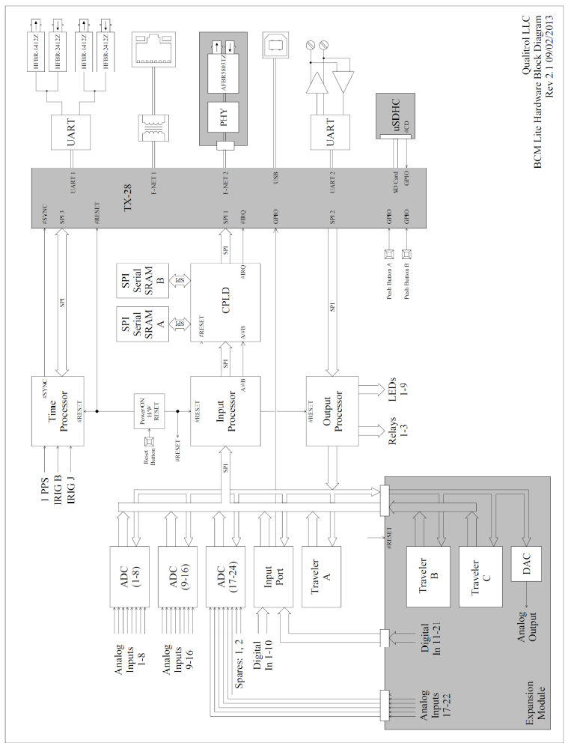

Inputs and Outputs

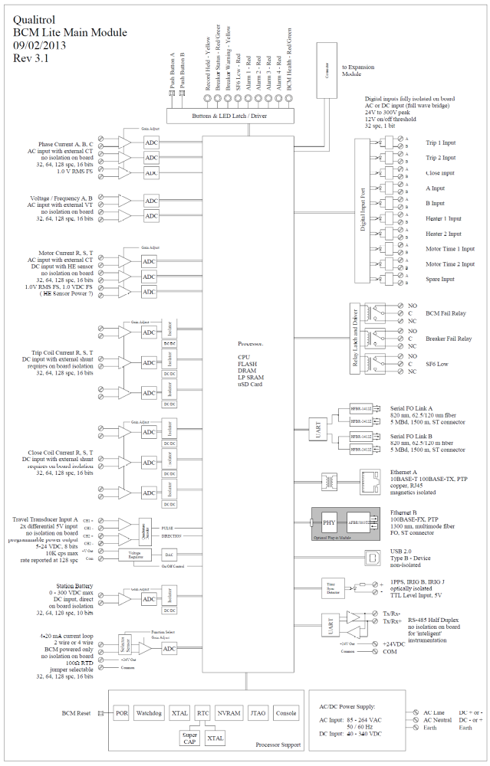
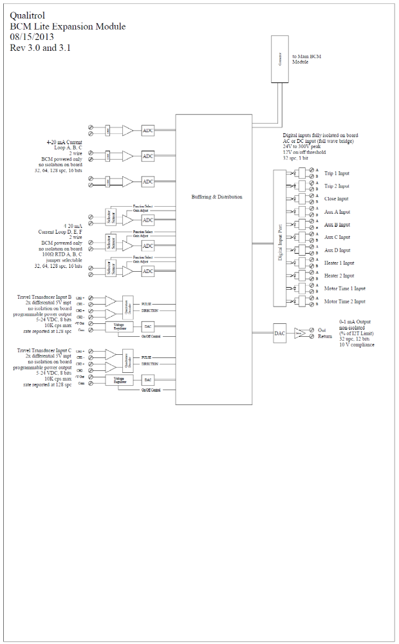

Data Transfer Scheme

